ARM Microservices - IIS Manual Hosting Guide

Overview
This document explains how to manually configure IIS hosting for ARM microservices:
Root Website: Default Web Site (for reference. Can create separate site as per implementation need)
Root Application Name: ARM_APP (This name is just for reference)
Root Physical Path: ARM_APP FOLDER PATH

Folder Structure
The main ARM_APP folder will have all microservice API folders as below:
ARM_APP FOLDER PATH
│
├── ARMNotificationHub
├── ARM_APIs
├── AxAuth
├── AxList
├── AxStructUtils
├── AxTstructData
└── AxUtils
└── AxPlugins (Optional. Use this site incase of plugin APIs)

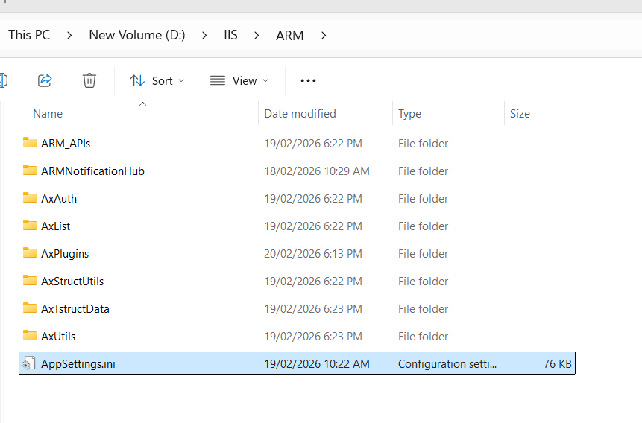

1. Prerequisites
- IIS must be installed
- ASP.NET Core Hosting Bundle (8.0), ASPNet core SDK.
- Ensure folder ARM_APP FOLDER PATH exists
- Ensure IIS_IUSRS has proper permissions
- All installations as per previous version of ARM.

2. Create Application Pools
All pools must use:
- .NET CLR Version: No Managed Code
- Managed Pipeline Mode: Integrated
Root App Pool: ARM_APP (This name is just for reference)
Microservice App Pools: (Recommended to have prefix of Root Apppool name for microservices as below for better readability)
ARM_APP_ARM_APIs
ARM_APP_ ARMNotificationHub
ARM_APP_AxAuth
ARM_APP_AxList
ARM_APP_AxStructUtils
ARM_APP_AxTstructData
ARM_APP_AxUtils
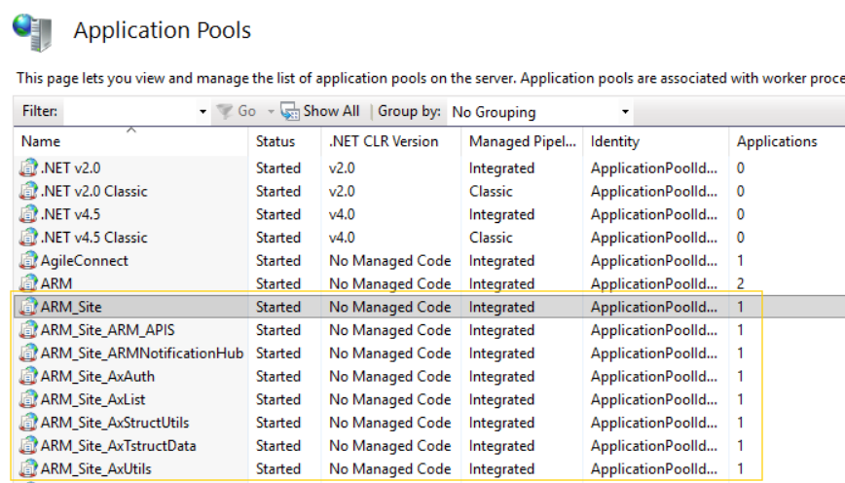

3. Create Root Application (ARM_APP)
Inside Default Web Site:
Alias: ARM_APP
Application Pool: ARM_APP
Physical Path: ARM_APP FOLDER PATH

4. Create Microservice Applications (ARM Microservice URLs) Inside ARM_APP
Each microservice application should be created under ARM_APP with:
Application Name | Application Pool | Folder Path
ARM_APIs | ARM_APP_ARM_APIs | ARM_APP FOLDER PATH\ARM_APIs
ARMNotificationHub | ARM_APP_ARMNotificationHub | ARM_APP FOLDER PATH\ARMNotificationHub
AxAuth | ARM_APP_AxAuth | ARM_APP FOLDER PATH\AxAuth
AxList | ARM_APP_AxList | ARM_APP FOLDER PATH\AxList
AxStructUtils | ARM_APP_AxStructUtils | ARM_APP FOLDER PATH\AxStructUtils
AxTstructData | ARM_APP_AxTstructData | ARM_APP FOLDER PATH\AxTstructData
AxUtils | ARM_APP_AxUtils | ARM_APP FOLDER PATH\AxUtils

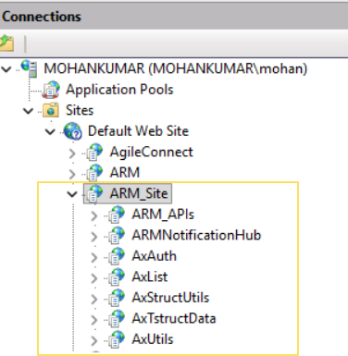

5. Permissions
Grant the following permissions on ARM_APP FOLDER PATH:
IIS_IUSRS, IUSR → Full access

6. Restart IIS
Run command: iisreset

7. Testing URLs for ARM Microservices
Run this URLs in postman (HTTP GET)/browser to check whether the microservice URLs are running fine or not.

<Your ARM URL>/ARM_APIs/api/v1/ARMAppStatus

<Your ARM URL>/ARMNotificationHub/api/v1/ARMAppStatus

<Your ARM URL>/AxAuth/api/v1/AppStatus

<Your ARM URL>/AxList/api/v1/AppStatus

<Your ARM URL>/AxUtils/api/v1/AppStatus

<Your ARM URL>/AxStructUtils/api/v1/AppStatus

<Your ARM URL>/AxTstructData/api/v1/AppStatus

All above URLS will return “Application running successfully” in JSON format.

Appsettings.ini configuration:
- Latest Appsettings.ini should be placed/replaced in the main root ARM_APP folder. It should not be placed inside the microservice application folders.
- IISREST/Application pool recycle (for all microservice applications) should be done in case of Appsettings.ini change.

Important Note:
The ARM Microservice application app names should not be changed and it should be one of the following:
ARMNotificationHub
ARM_APIs
AxAuth
AxList
AxStructUtils
AxTstructData
AxUtils
AxPlugins (Optional. Use this site incase of plugin APIs)

